Domain Controller lab setup:
First go ahead and download the iso from this link
[ https://info.microsoft.com/ww-landing-windows-server-2022.html ]

After registering you will get to this window and then download the iso

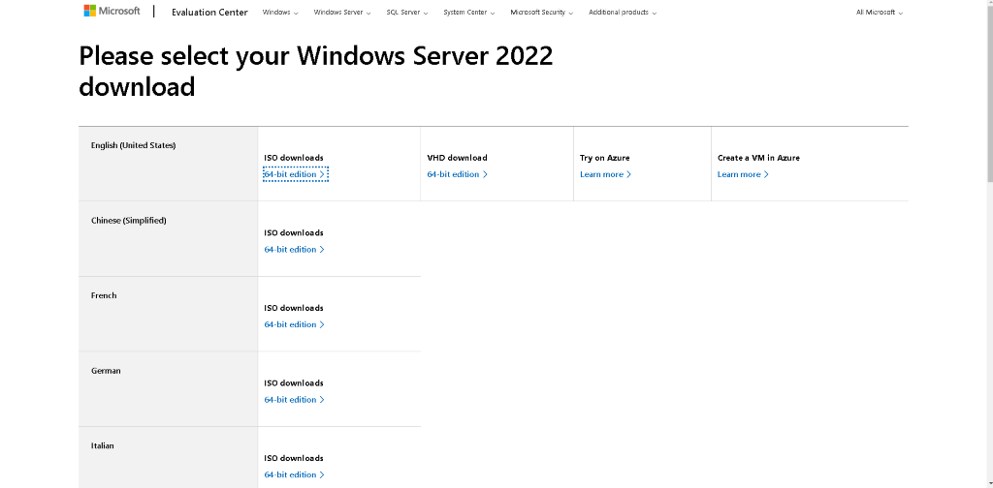
Now go to the VMware workstation and select the server iso and go ahead as shown in the pictures mentioned below:
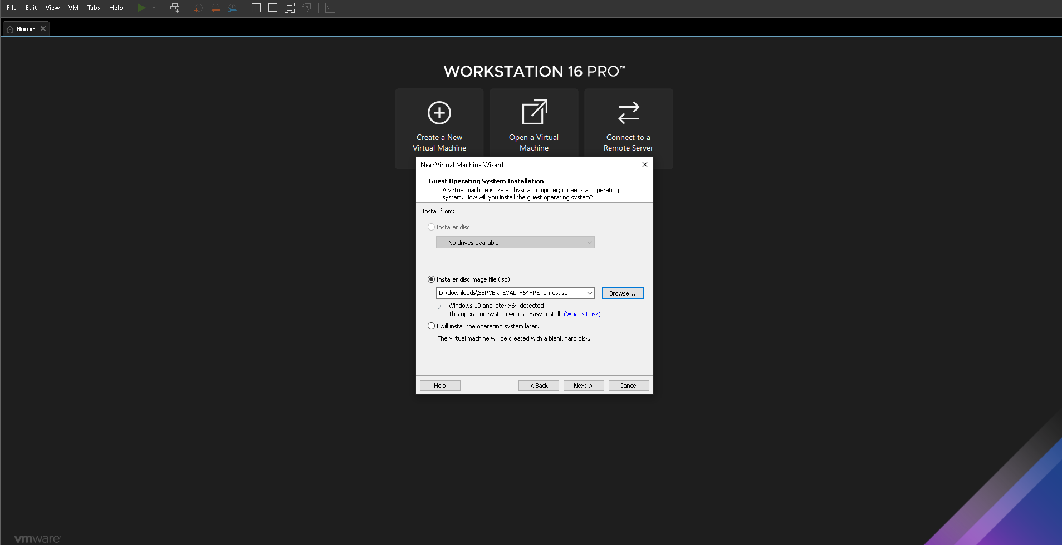

Select Windows 10 Home as version
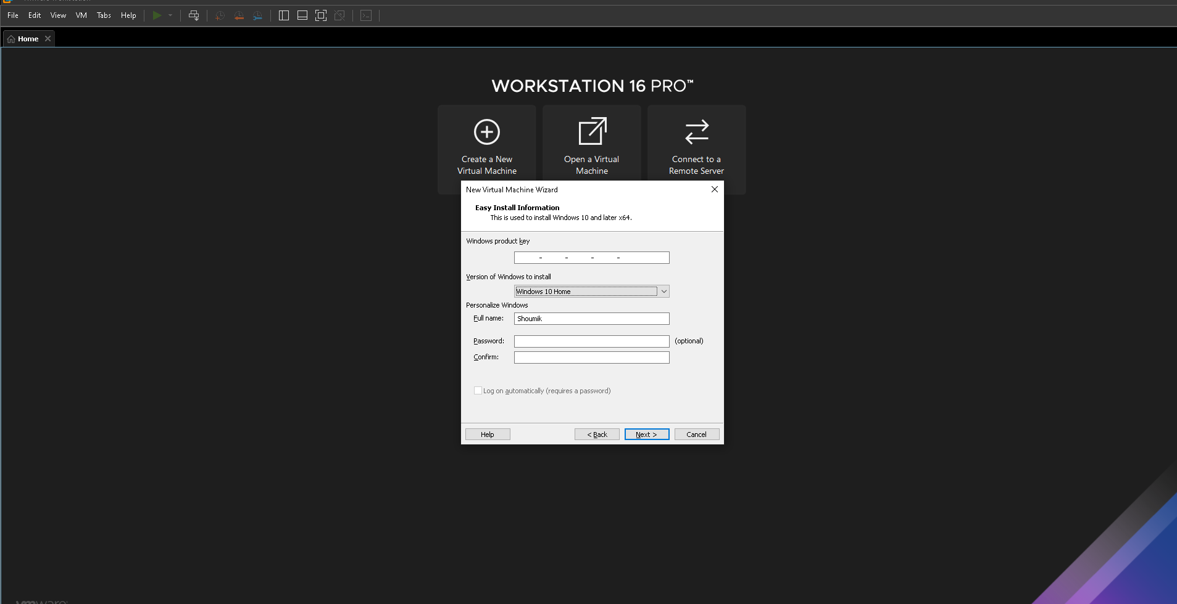

Select your preferable storage area and perform as shown:
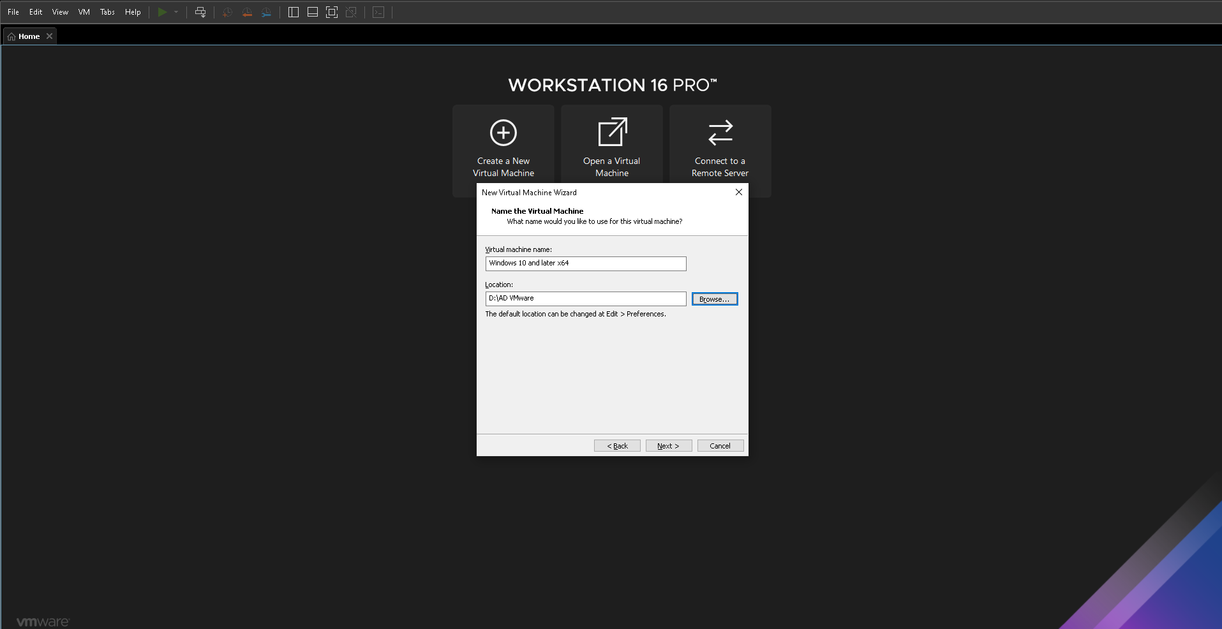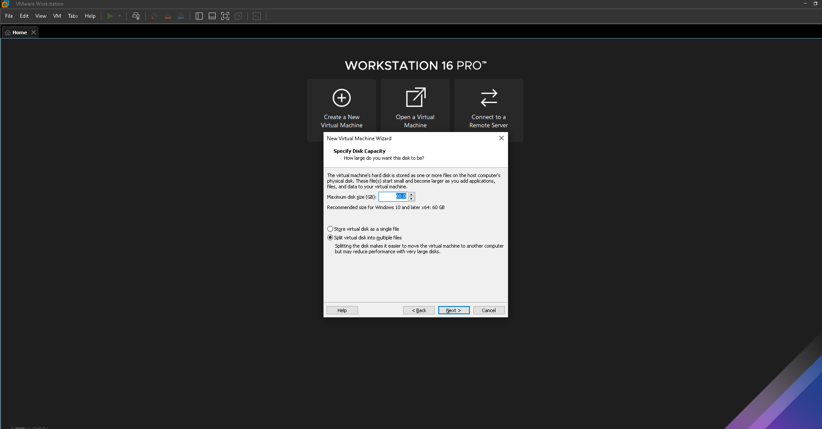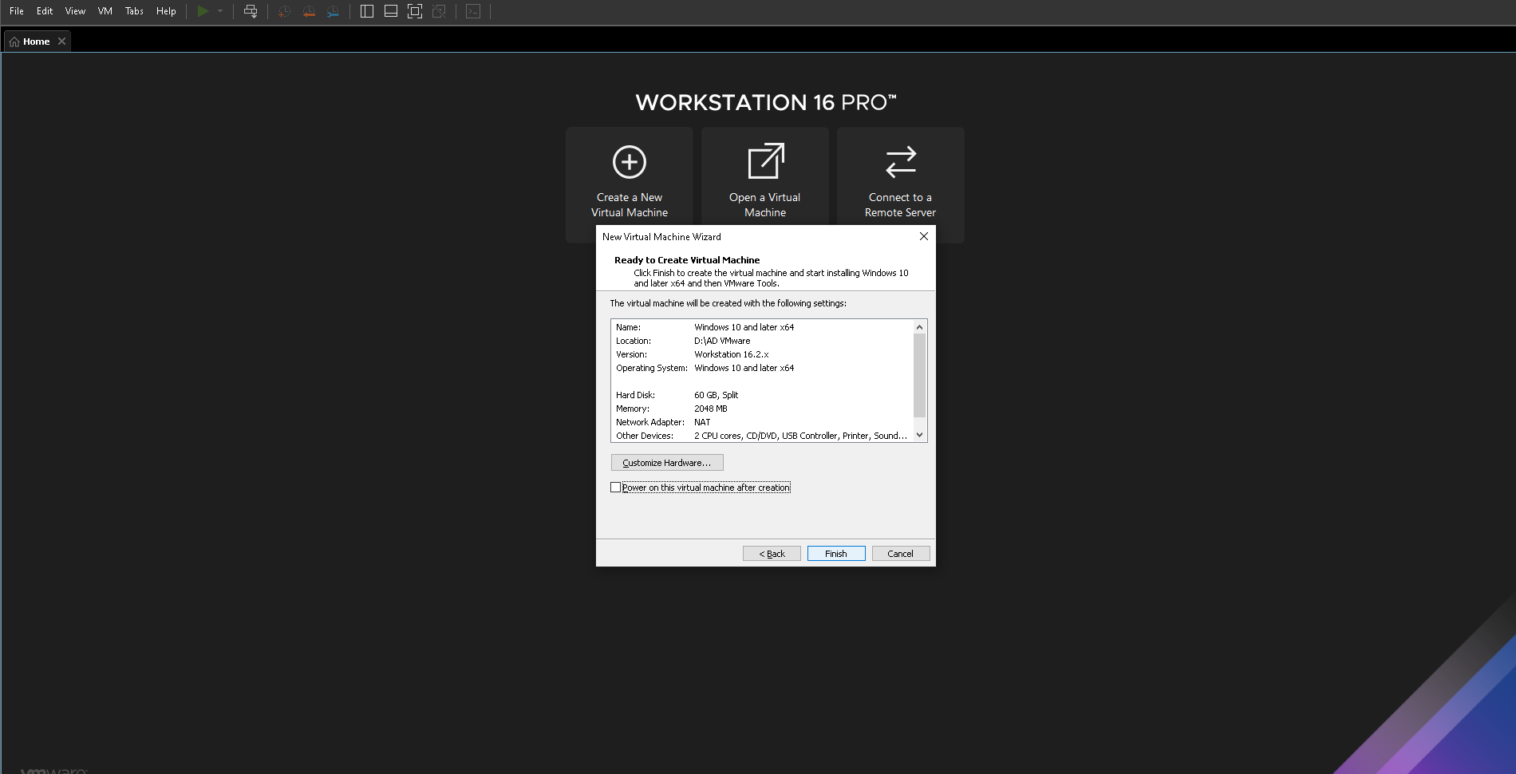

Now go to the edit virtual machine setting and remove the floppy device
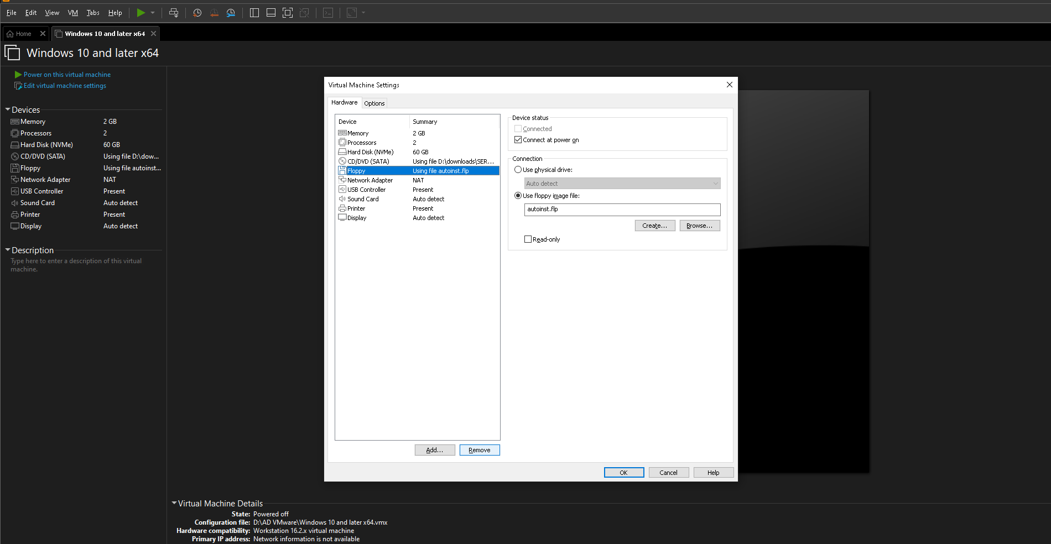

Now power on the virtual machine and then you will be directed to Microsoft server Operating System setup where you will need to select the Standard Evaluation (Desktop Version)
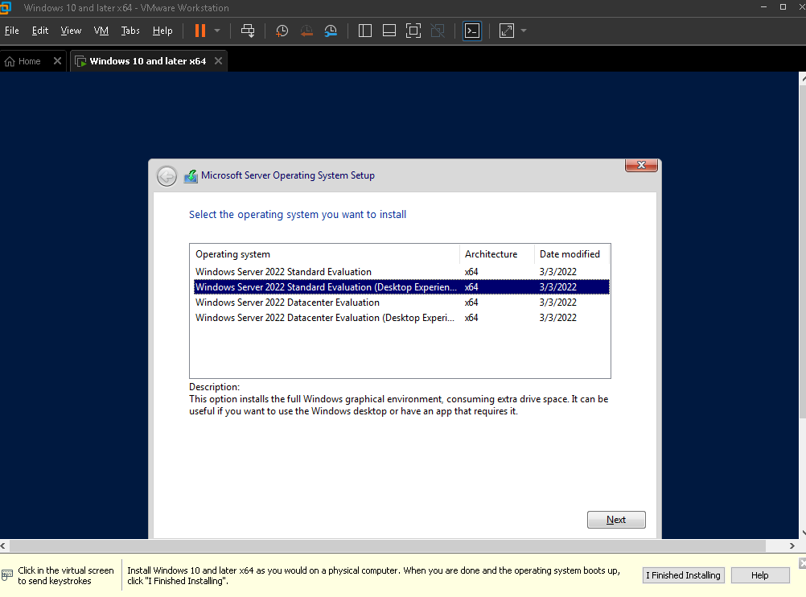

Now select New option and perform as shown where your drive will get partitioned as shown
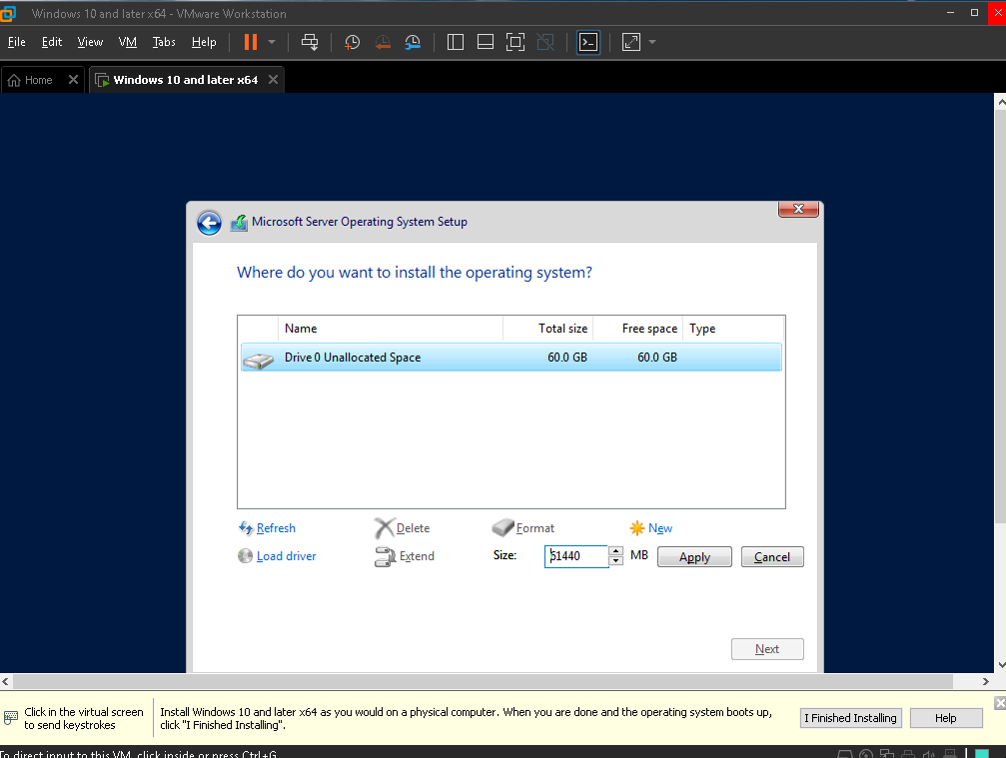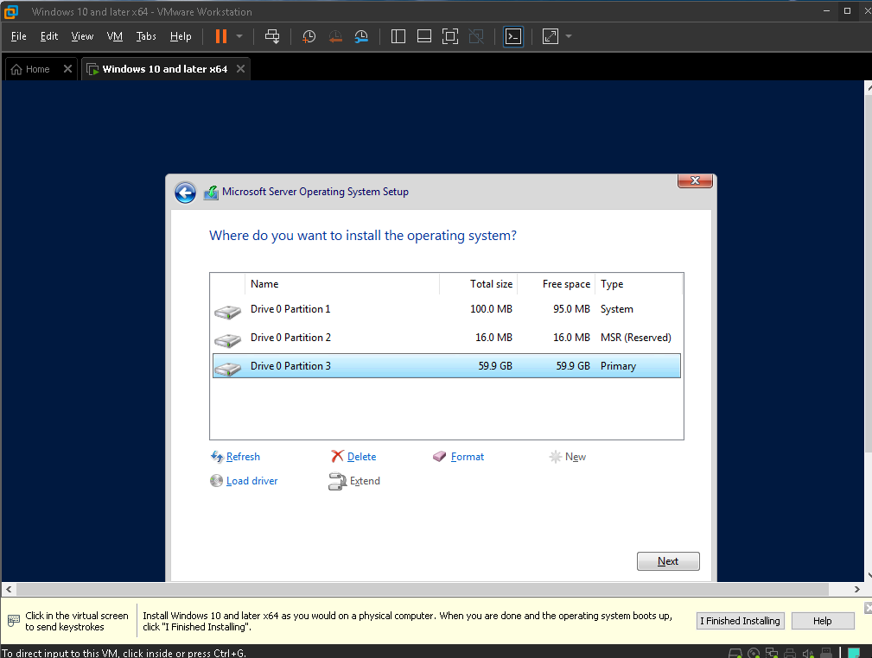

Now select the password you want to and we are ready to go.
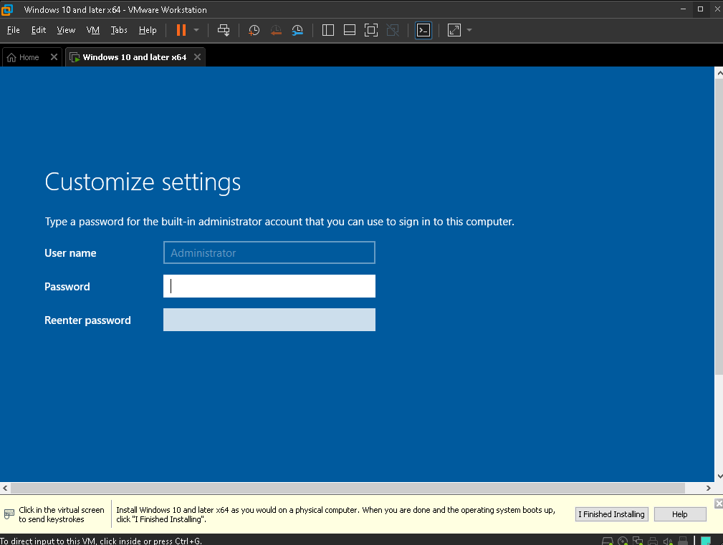

To get a full view of the windows in workstation go to VM>install VMware tools and perform as shown.
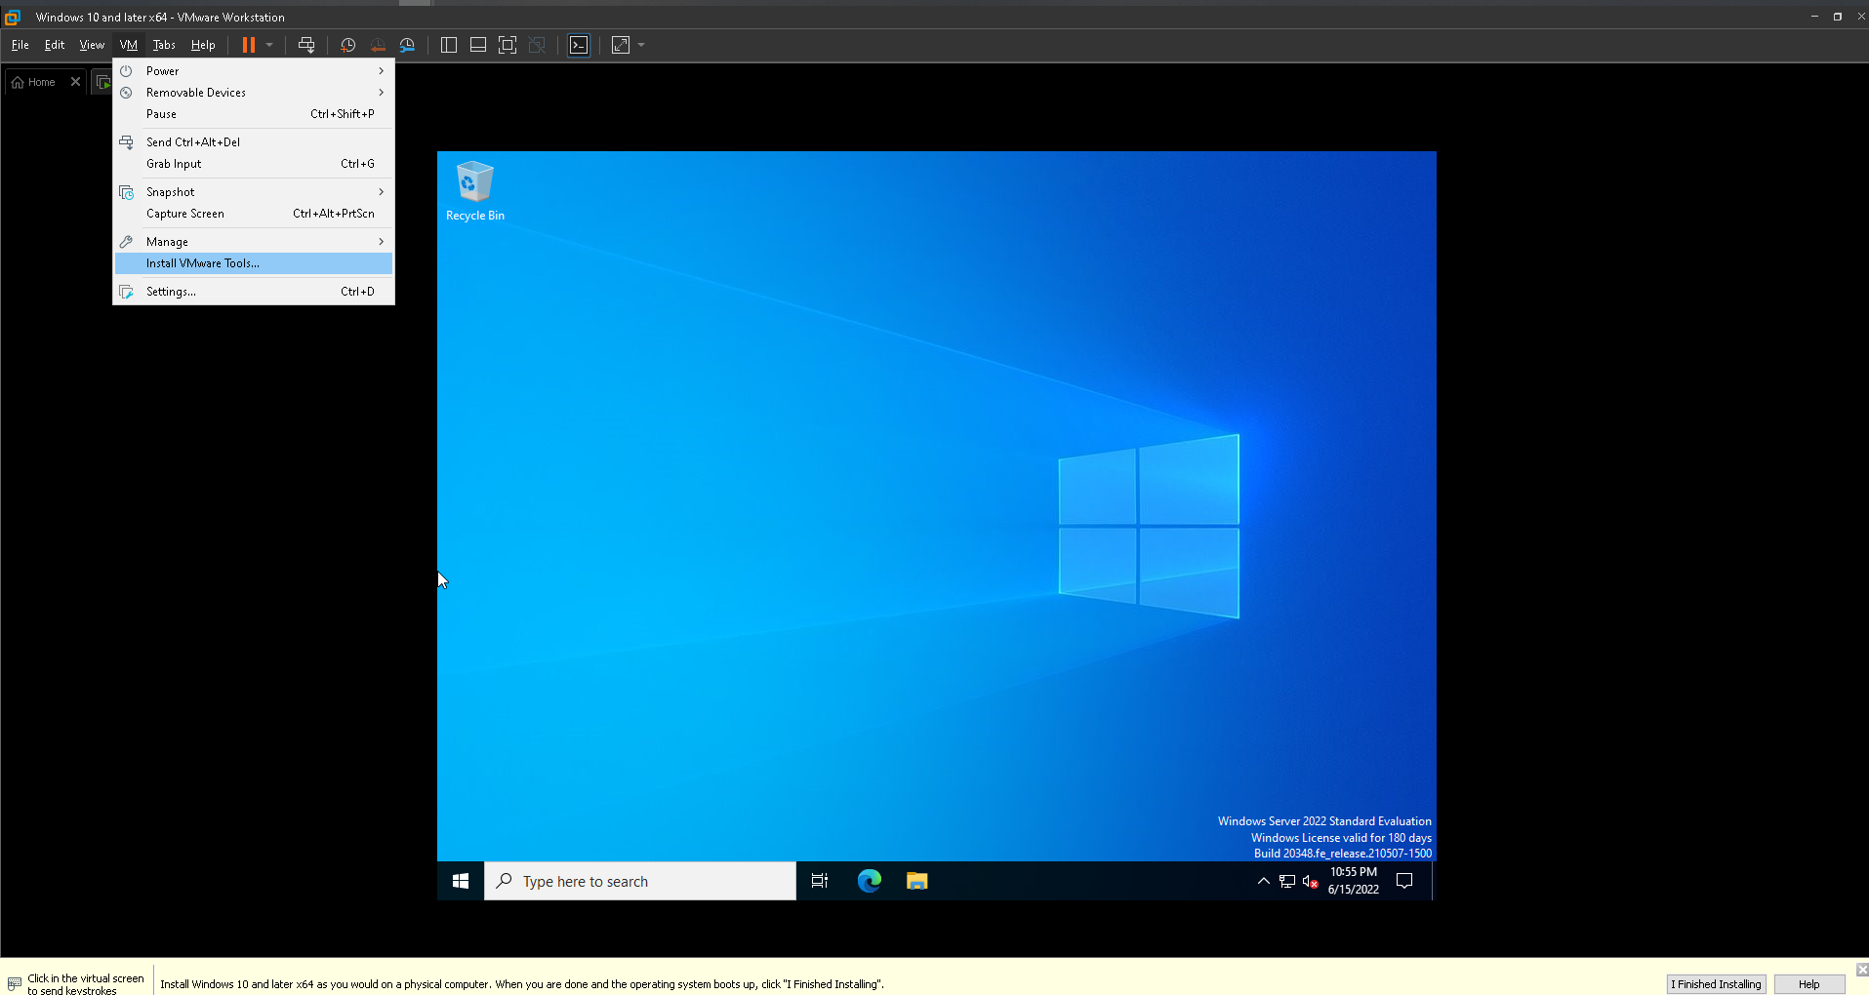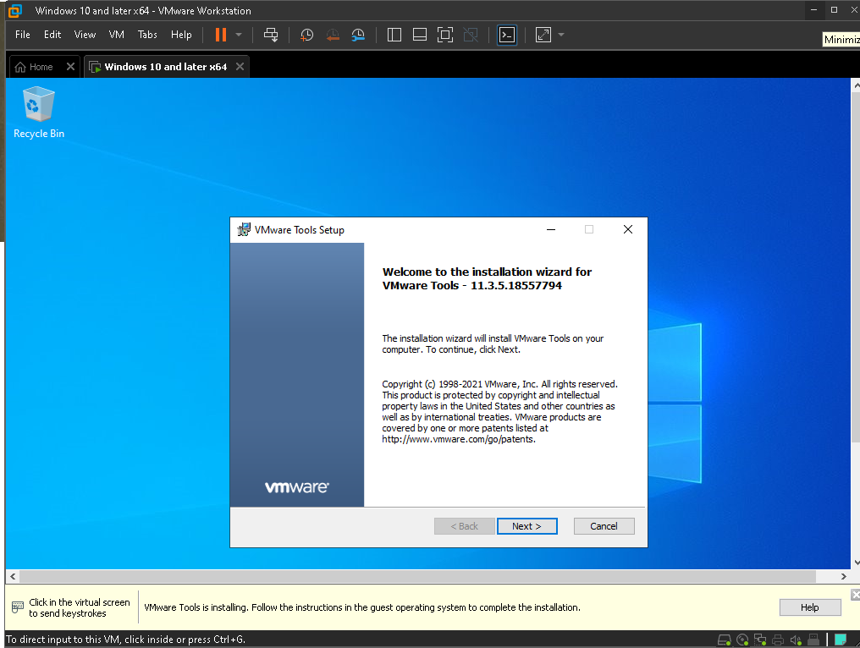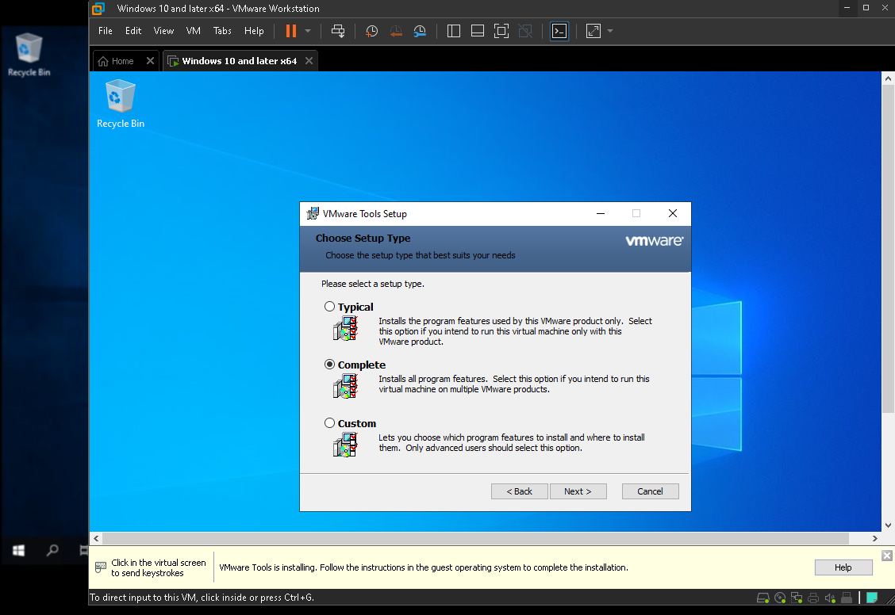

Now you need to change the computer name. In order to do that go to view your pc name.
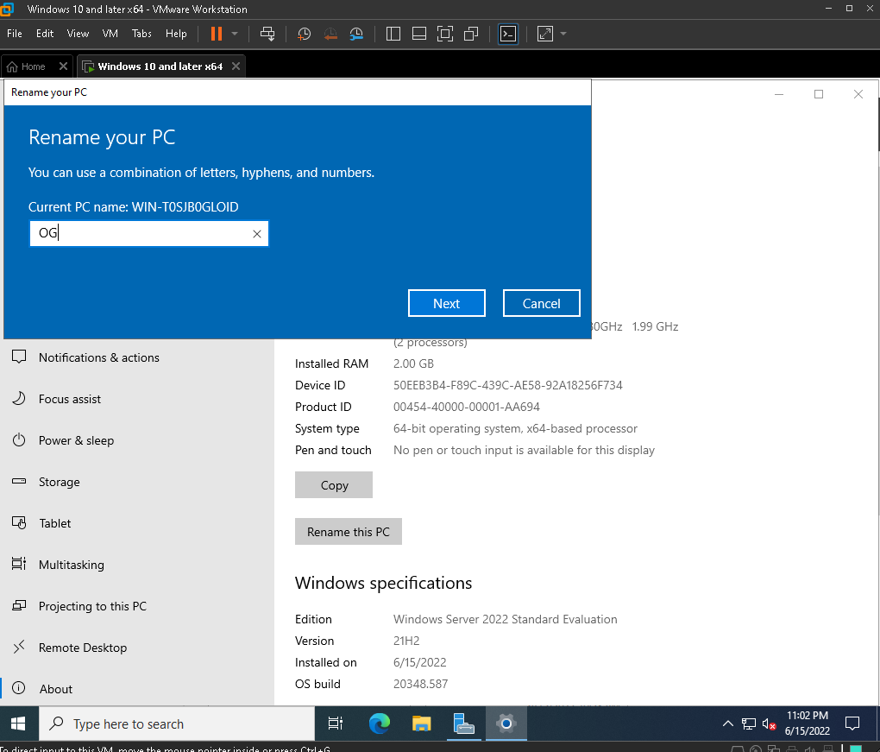

Now the exiting part begins:
Lets install a domain controller. Perform as shown:
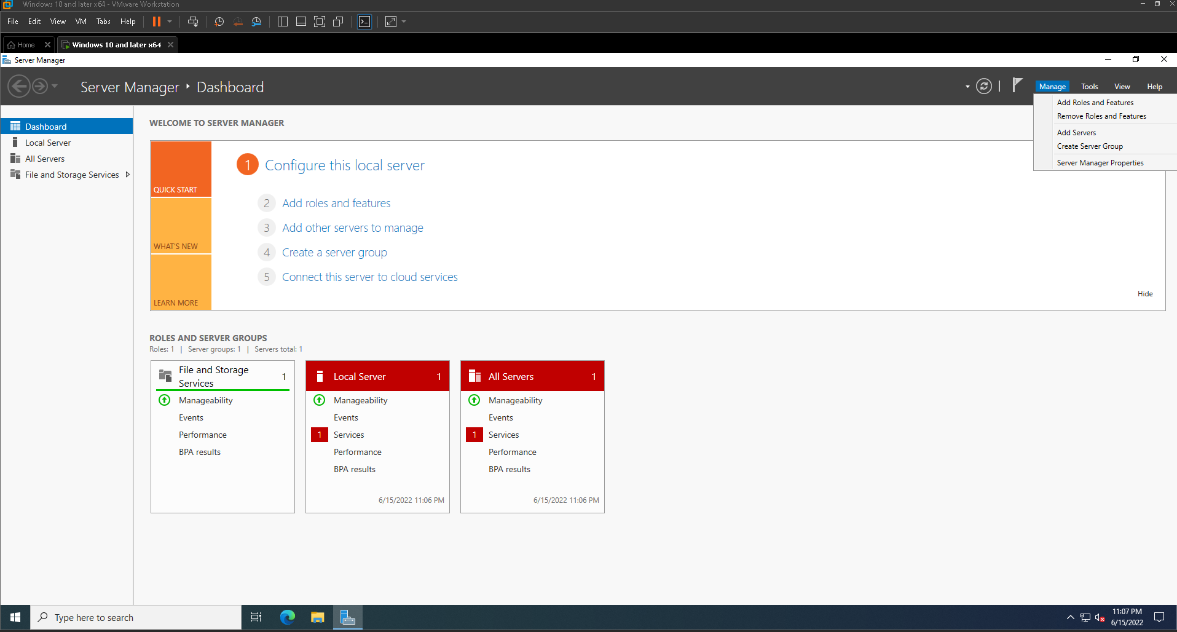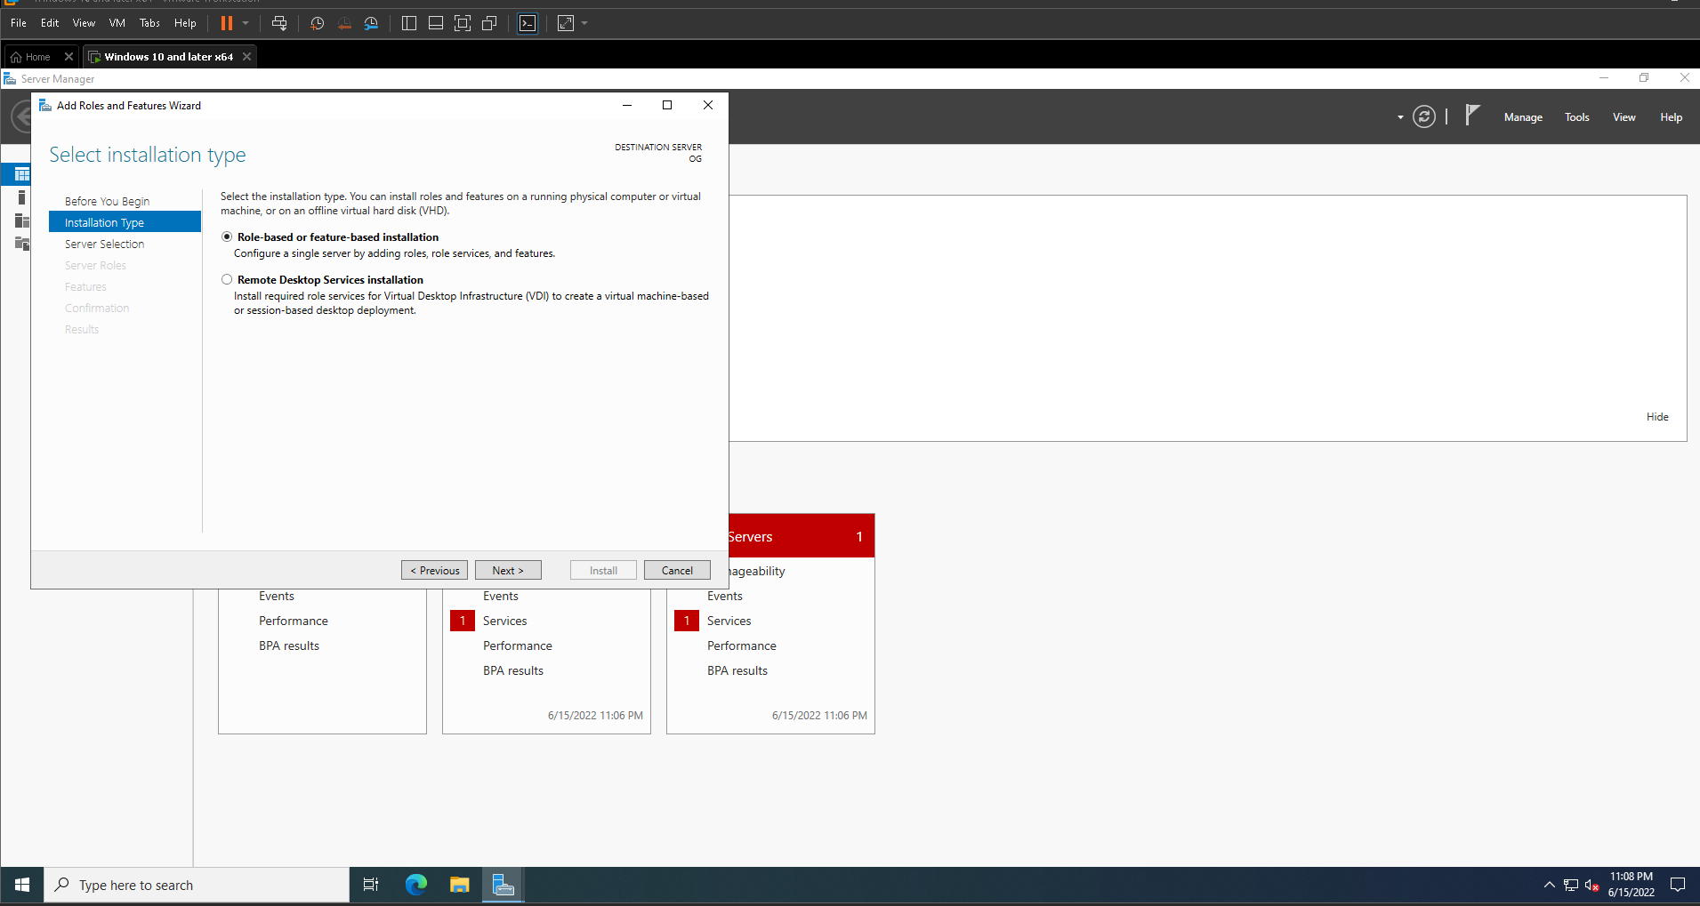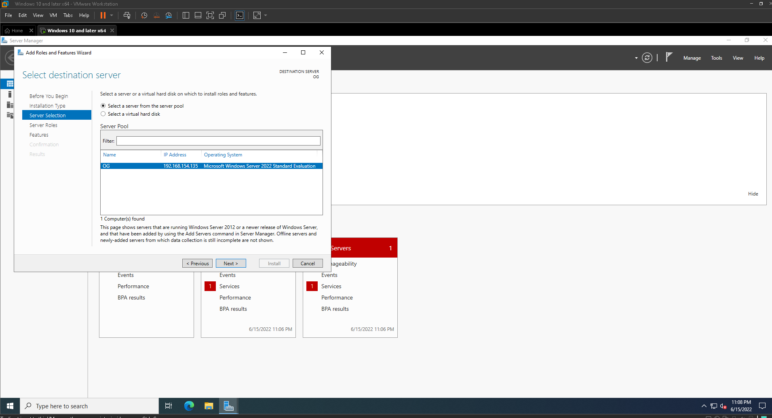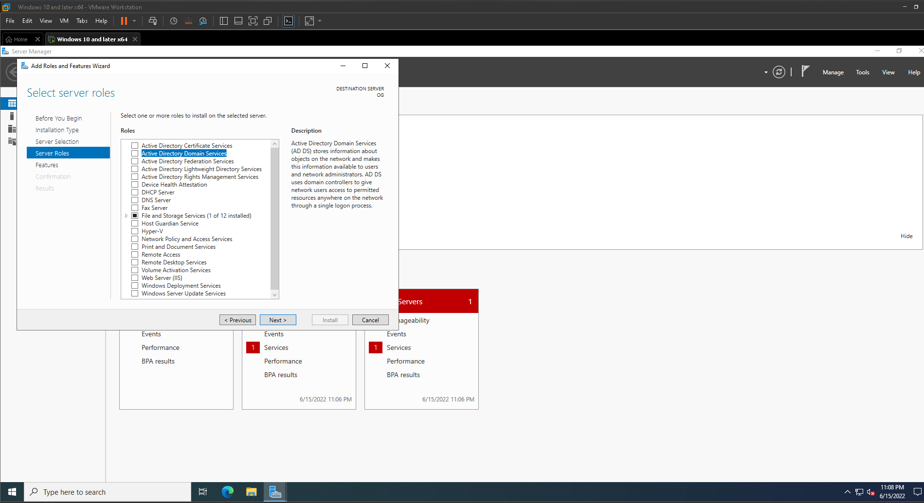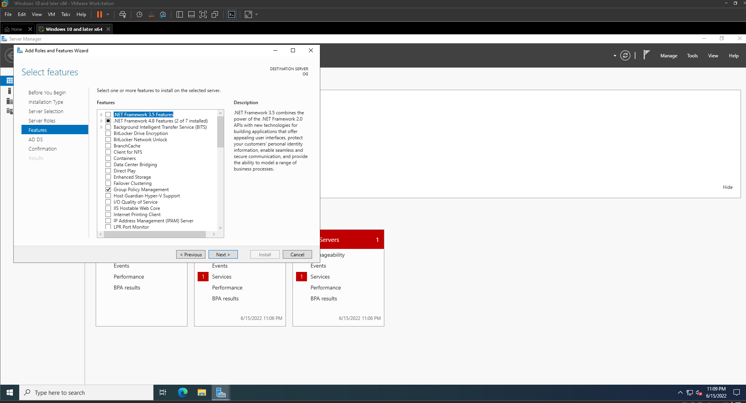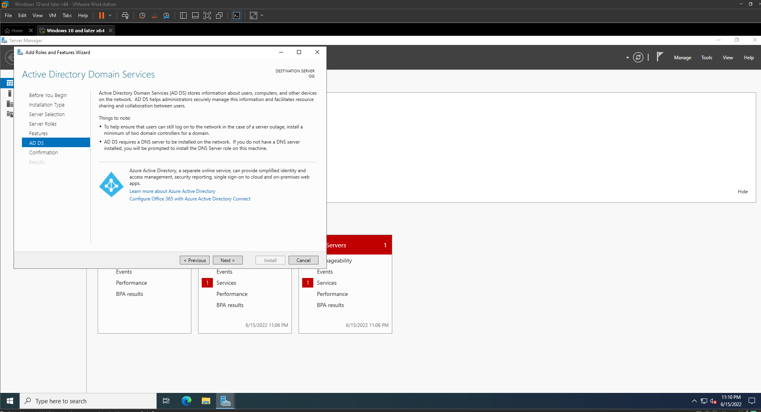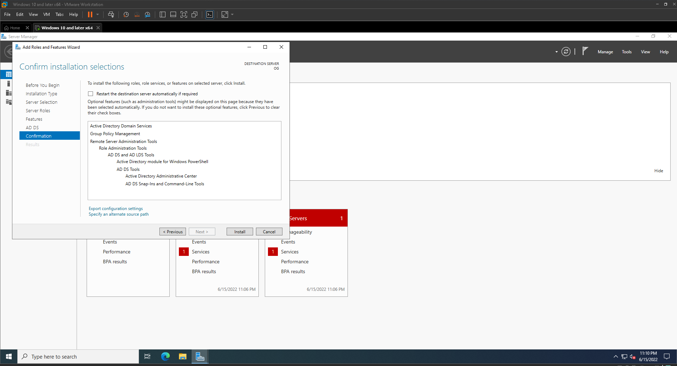

After installing go to the notification area where it shows the little flag with and exclamation and click on Promote this server to a domain controller.
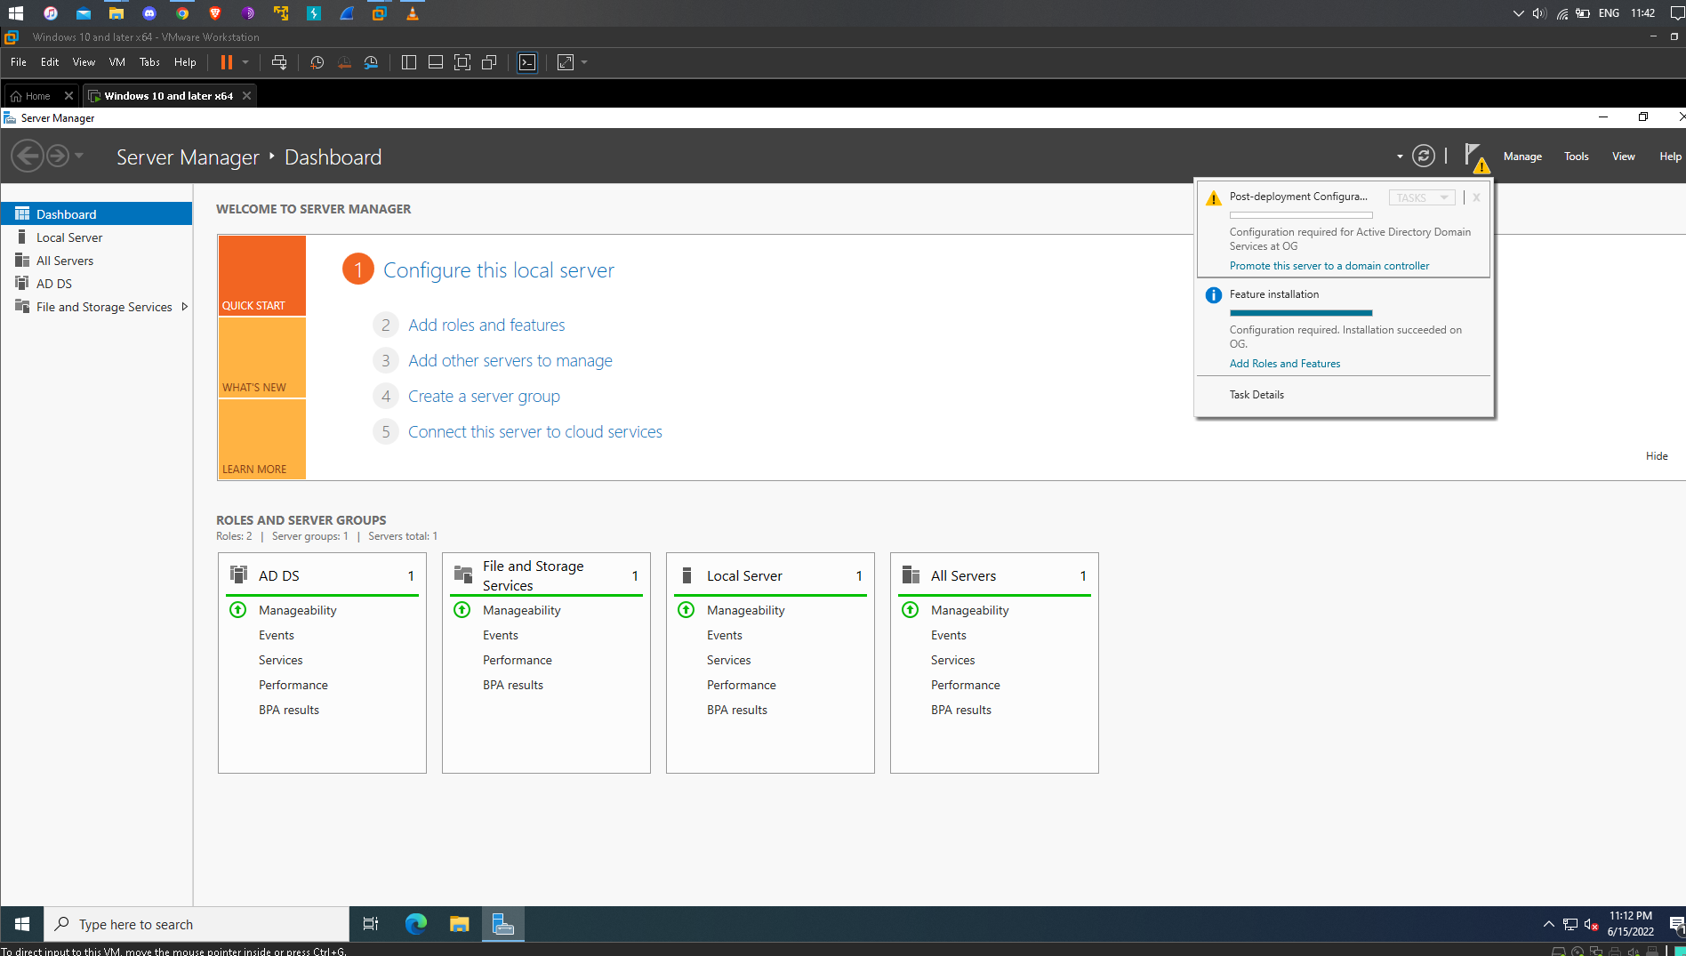

Now at Deployment Configuration select Add a new forest and give a name to root domain with .local at the end of the name and then perform the as shown.
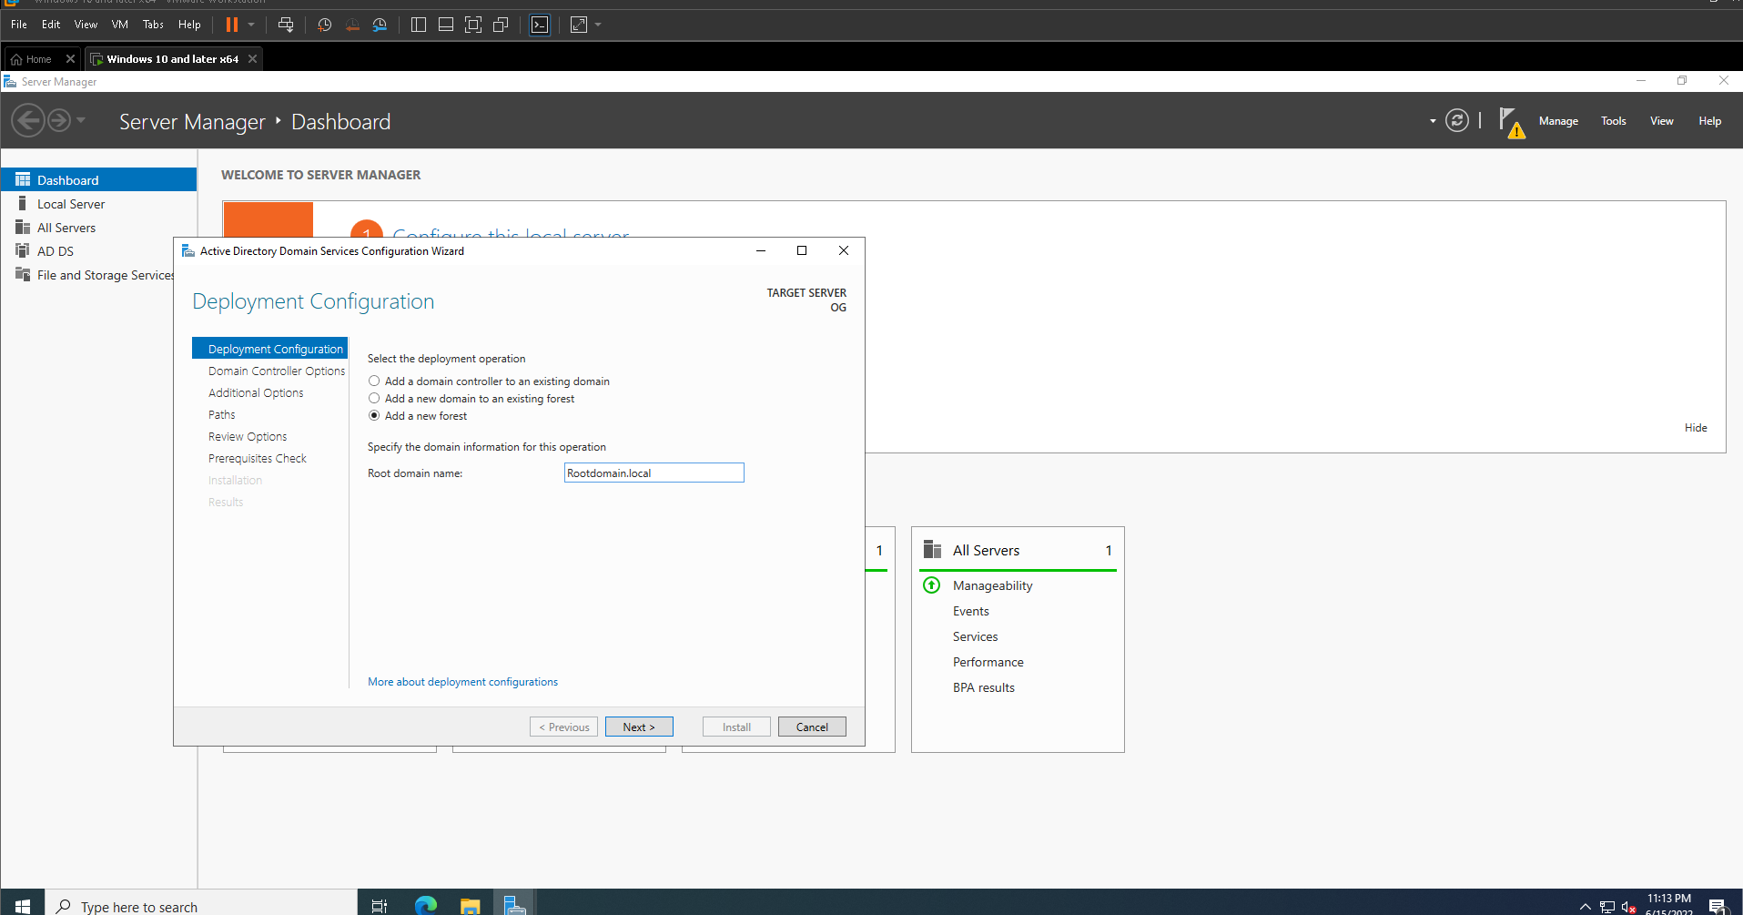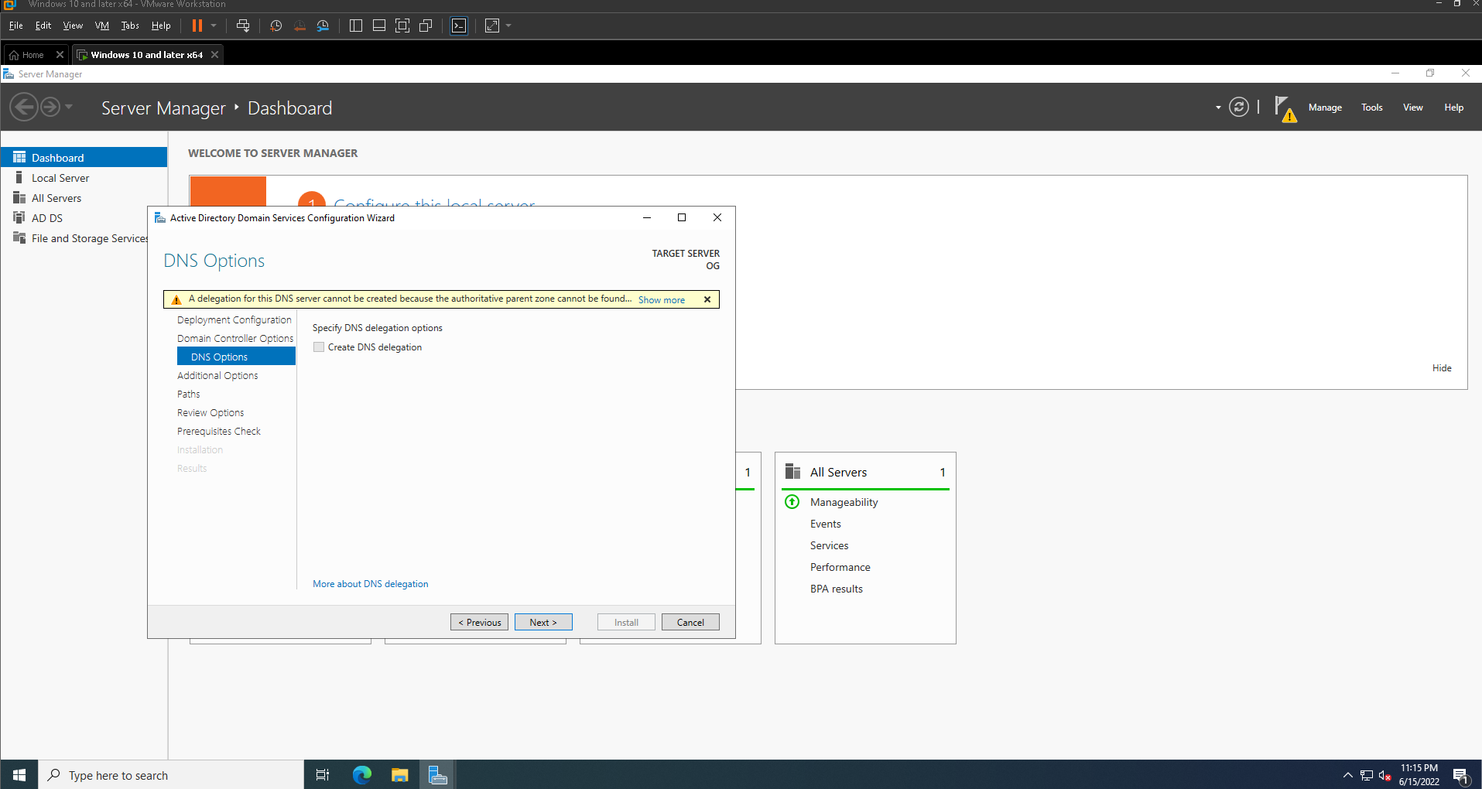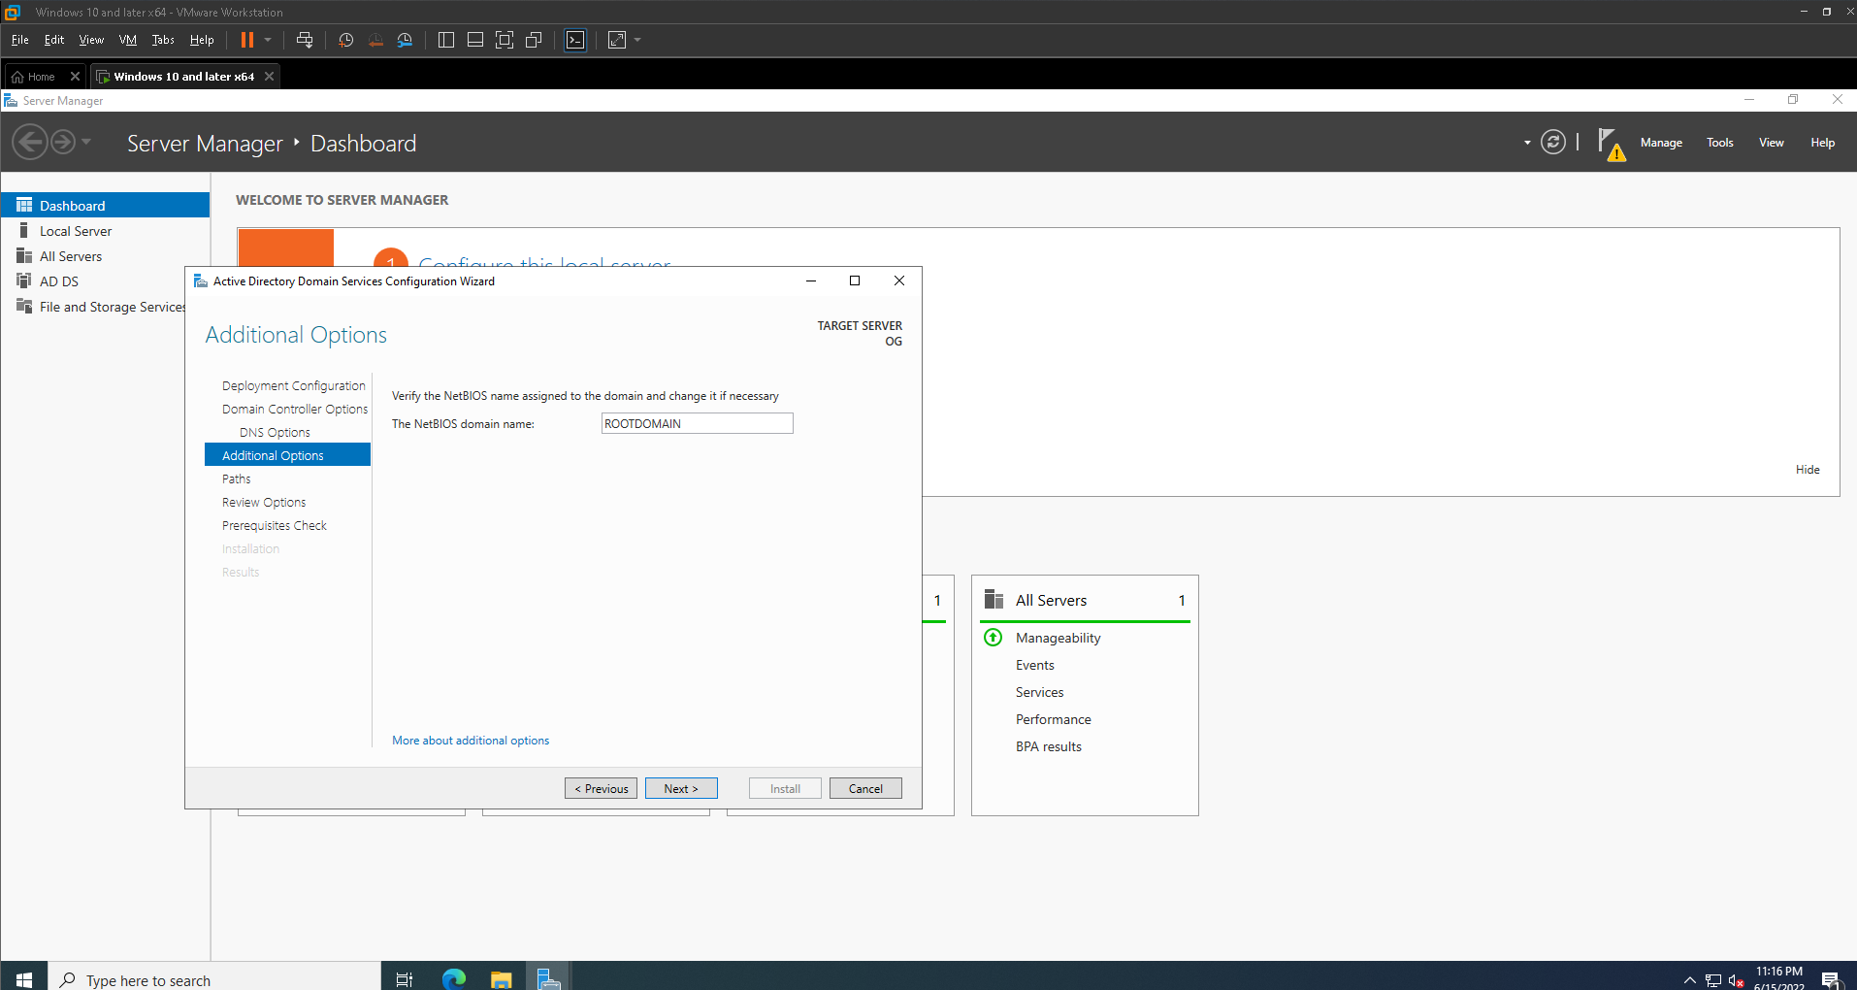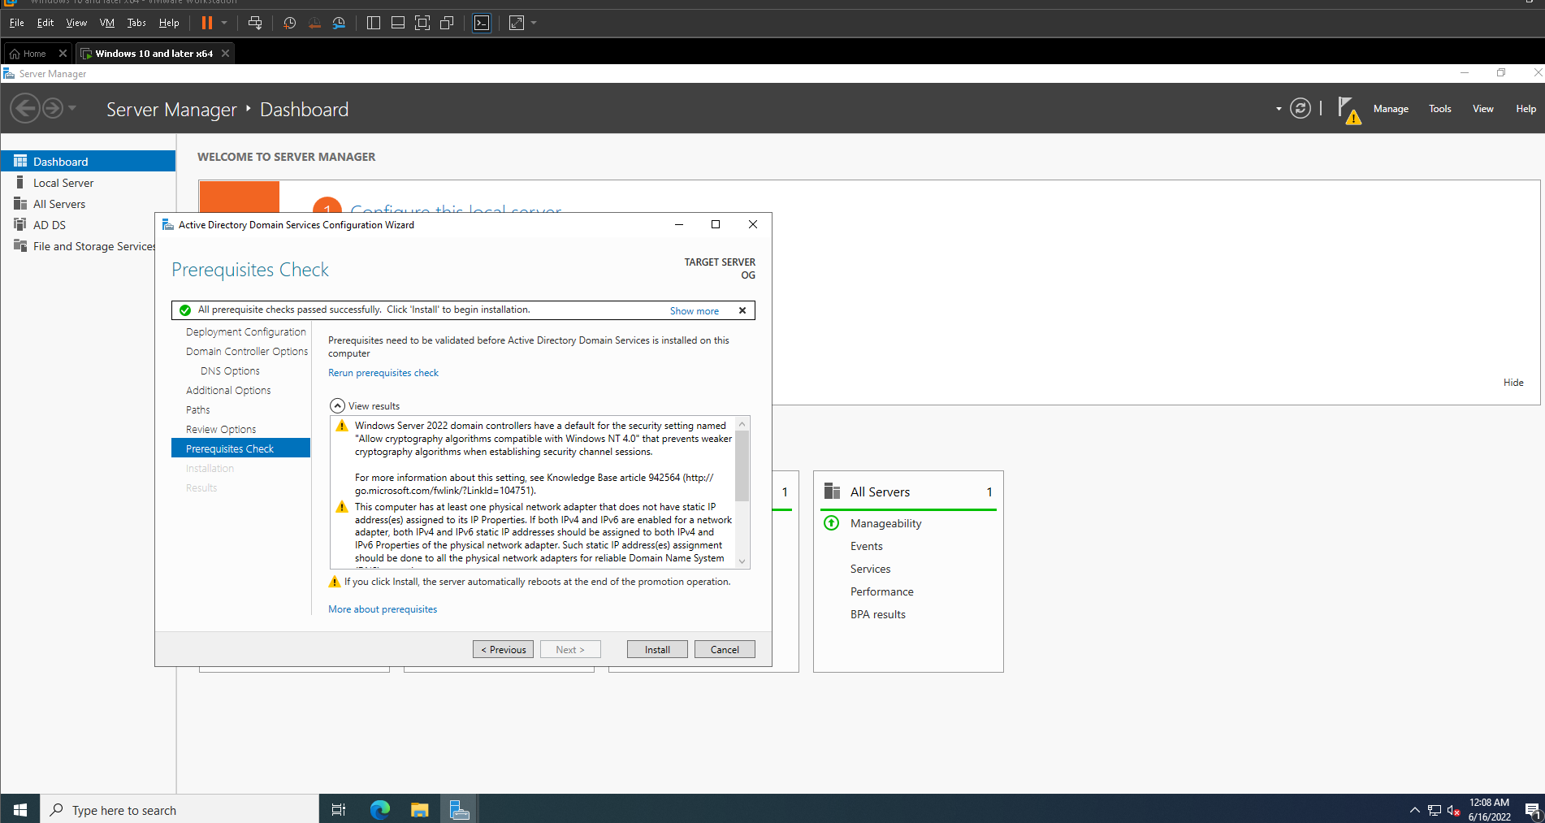

Now finally install and then it will reboot the machine and then you are ready to go.

